Executive Master EPAC

Cluster 1

EU Public Affairs

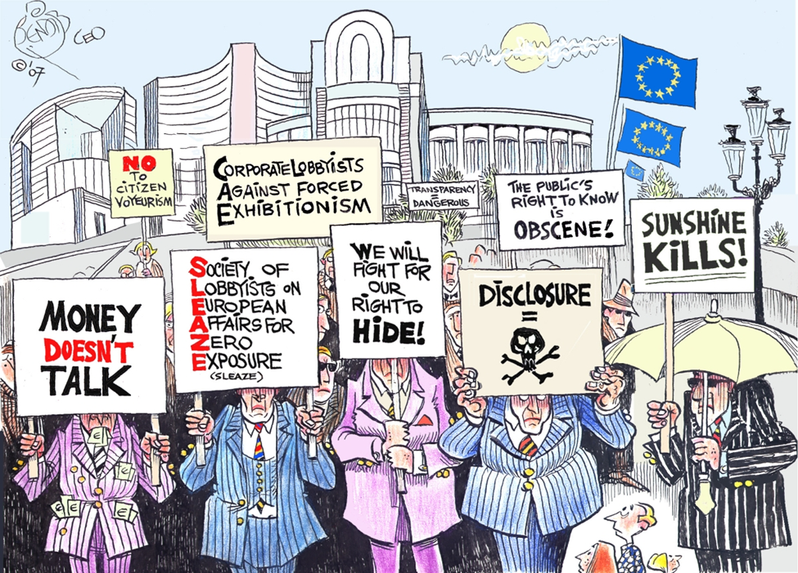

15 crédit - 2025-2026 - 1st Semester

# Trainer:

Name : Paul Shotton PhD,

Email : [paul@advocacystrategy.com](mailto:paul@advocacystrategy.com)

Tel : +31 624221664

Responsibilities: Teaching, developing course materials and syllabi, final assessment.

OFFICE HOURS:

Name: Marta Ibero, [martaibero@hotmail.com](mailto:martaibero@hotmail.com), tel +32 497324207

Responsabilities: **One-to-one meeting, in-person,** on **Zoom,** or by **appointment.** Reviewing lecture content or clearing up confusion, giving feedback on final strategic advocacy campaign plan. If needed, some guidance or coaching on navigating the NGO job market.

# Learning outcomes:

1. Interpret a complex EU legislative proposal and relate its key articles to the interests of a specific organization.
2. Formulate SMART advocacy objectives that respond to the legislative and political context.
3. Develop a clear and compelling message house, including arguments, frames, and narratives tailored to target audiences.
4. Map and prioritize key stakeholders using structured tools and assess their influence and alignment.
5. Design a strategic advocacy campaign plan, including tactics, timing, and success indicators (KPIs).
6. Pitch their campaign plan professionally in a structured, evidence-based, and persuasive 20-minute presentation.

# Cluster Overview

Student completing this cluster will develop an advocacy campaign and in doing so understand the fundamentals of advocacy within the European Union. Elected officials and member states are not the only powerful actors in European Union decision-making. The 13,000+ EU interest groups such as NGOs, multinationals, trade associations and their consultants and lawyers play a major role in drafting, adopting and implementing EU policy and legislation.

Through a real case study of an ongoing legislative proposal under the ordinary legislative procedure, students will understand the steps of the advocacy process and acquire practical knowledge and skills of key advocacy tools. Using this knowledge and tools students will research, design and present a lobbying campaign focusing on the European Union’s three main legislative institutions, namely the European Commission, the European Parliament and the Council of Ministers.

During the course students will interact with lobbyists, legislators and other policy-making actors through case studies and guest lectures. Students will be assessed through a portfolio of professional products and a pitch presentation. The professional products (i.e., stakeholder maps, message houses, position papers) will be built using knowledge from the case study.

**CASE STUDY FOCUS**:

Utilising the "Green Claims" legislative proposal as the primary case study, students organised by groups (4/5 persons) will create professional products such as stakeholder maps, message frameworks, and position papers.

Most real-world problems are solved in teams, the case study also will help students to improve in articulating ideas, listening, giving feedback, resolving conflicts, build and test leadership skills.

# The 7-step Advocacy Method

The 7-Step method provides a sequential framework to acquire the knowledge, skills and tools required for successful advocacy campaigns. The method is best acquired by participants when explored and implemented through the application of real-life examples and existing strategy. Your interest group has the goals and knowledge that Advocacy Strategy and its method can translate into high-impact advocacy strategies.

Our 7-step method is ordered as follows:

1. **Prioritize:** How to identify and define priorities.
2. **Intelligence Gathering:** How to get the information you need.
3. **Position:** How to build the right positions.
4. **Information Management:** How to manage all your information.
5. **Engage:** How to engage with your stakeholders
6. **Manage:** How to manage your advocacy.
7. **Evaluate:** How to evaluate and improve.

The 7-step advocacy method is a framework of the advocacy practice.

1. It provides a methodology to **deconstruct the advocacy process**. It is based on strength across the entire advocacy process and not in just one or two areas.
2. Providing a comprehensive framework making your advocacy strategy more complete, which you need to be successful **across a complete set of activities** from one campaign to the next.
3. It delivers a **long-term improvement to your advocacy practice**. By adapting your advocacy practice to the method, you initiate long-term changes to the way in which you work individually and as a team.
4. It makes your **advocacy strategy more adaptable and agile**. As internal and external events change, using our method makes it easier to react to KPI and understand what aspects of the strategy need to adapt as well as determine the consequences for other areas of your strategy.

To further explore the 7-steps of advocacy method as well as the free advocacy tools, please visit: [www.advocacy-academy.com](http://www.advocacy-academy.com)

# Organisation of the cluster: Designing and Pitching a Public Affairs Campaign

|  |  |  |  |  |  |  |
| --- | --- | --- | --- | --- | --- | --- |
| Session | Timing | Topic | Duration | Content | Homework & Assignments | Support |
| 1 | Week 1  20 nov | Course Launch & Case Study Introduction (3 hours) | 3 hours (1/2 day) | - Overview of course and assessment - Introduction to legislative case (e.g. Green Claims Directive) - Key articles and organizational relevance - Overview of 4 deliverables and final pitch - Advocacy Academy orientation | - 📺 Watch video lectures on:   * What is Public Affairs, Advocacy and Lobbying; * From Issues to Advocacy Priorities, * Setting SMART Advocacy Priorities .   - ✍️ Draft SMART objectives (2–3 weeks) | 🕐 Marta Office Hours (Week 2)  Optional- 40’ meeting p/group to support on:   * Understanding the organization. (mission, vision, add value). * Understanding the legislation and challenges for definition of smart objectives.   Total hours:   * 4 hours with students. |
| 2 | Week 4  11 Dec | SMART Objectives Workshop (3 hours) | 3 hours (1/2 day) | - Review and refine draft SMART objectives - Peer feedback and good practice examples - Aligning objectives with policymaking timeline | - 📺 Watch:   * Message House video * Storytelling * Technical communication * How to do Stakeholder Mapping   - 📝 Assignment 1: Draft Message House using template - 📺 Watch: Stakeholder Mapping video series - 📝 Assignment 2: Draft Stakeholder Map using Excel tool (3–4 weeks) | 🕐 Marta Office Hours (Week 5–6)  Mandatory - 40’ meeting p/g to support on:   * Definition of SMART objectives.   Total hours:   * 3h course * 4h with students. |
| 3 | Week 8  10 January | Messaging & Mapping Workshop (7 hours) | 7 hours (all day) | - Workshop: messaging strategy (frames, narratives) - Workshop: stakeholder mapping and classification - Integration of message and mapping | - 📺 Watch:   * Direct & Indirect Engagement Strategies, * Building Coalitions * Action Plans * KPIs   - 📝 Draft Campaign Plan (Action Plan Template) - 📝 Outline Pitch Presentation (3–4 weeks) | 🕐 Marta Office Hours (Week 9–10)  Mandatory- 40’ meeting p/g to support on:   * Stakeholder mapping * Message house   Total hours:   * 3h course * 4h with students. |
| 4 | Week 12  27 January | Campaign Planning Workshop (3 hours) | 3 hours  (1/2 day) | - Tactics: direct/indirect engagement, coalitions - Structuring action plans, timelines, KPIs - Tips on pitch presentation | - Finalise deliverables - Rehearse pitch | 🕐 Marta Office Hours  Optional check-in 40’ p/g before pitch  Total hours:   * 4 hours with students. |
| Final Pitch | Week 15  14 Feb | Pitch Presentation (+/-5 hours) | 7 hours (all day) | - 20-minute individual presentation - Q&A with assessors | Submit all 4 deliverables for grading: 1. SMART Objectives 2. Message House 3. Stakeholder Map 4. Campaign Plan | Feedback & Grading  Optional coaching session 20’ p/s after pitch on NGO job market:  Total hours:   * 2 hours |

# Evaluation :

## Assessment:

* 30% for the presentation
* 70% for the portfolio

### Resits:

Thus, students will have one initial and one resit opportunity per year to take and pass the assessments.

### Passing Grade:

The student receives a passing grade if all interim products have been submitted and the total grade is higher than 5.5.

Presentations will be in the last two weeks. Submission of written work will be at end of terms 1 & 2.

## Presentation

Group presentation of group analysis and campaign to case study providers. Presentations will take place in week 14.

Presentation 30 minutes and must include:

* Vision, objective & arguments.
* Key demands (requests) from policymakers

## Portfolio

Present an individual lobbying campaign related to your case study that includes:

1. A set of SMART Objectives
2. Message House
3. A Stakeholder Mapping
4. Action Plan

# References :

### Core Reading:

Hardacre, A.. (2020). How to Work with the EU Institutions: A Practical Guide to Successful Public Affairs in the EU. John Harper Publishing. ISBN: 9781838089818: <https://www.johnharperpublishing.co.uk/how-to-work-with-the-eu-institutions-a-practical-guide-to-successful-public-affairs-in-the-eu/>

### Recommended Reading (Books):

* Peace Child International (2009). Advocacy Toolkit.
* European Environmental Bureau (2015). ENV.net Advocacy Tool. How to influence environmental policy through effective advocacy Coen, D., & Richardson, J. (Eds.). (2009). Lobbying the European Union: institutions, actors, and issues. Oxford University Press.
* Greenwood, J. (2017). Interest representation in the European Union. Springer.
* Richardson, J., & Mazey, S. (Eds.). (2015). European Union: power and policymaking. Routledge.
* Shotton, P. A., & Nixon, M. P. G. (Eds.). (2015). Lobbying the European Union: Changing Minds, Changing Times. Ashgate Publishing, Ltd.
* van Schendelen, M. P., & Van Schendelen, R. (2010). More Machiavelli in Brussels: The art of lobbying the EU. Amsterdam University Press.
* Wallace, H., Pollack, M. A., & Young, A. R. (Eds.). (2015). Policymaking in the European Union. Oxford University Press, USA.
* Zetter, L. (2014). Lobbying 3e: The art of political persuasion. Harriman House Limited.

### Key journals for this course include:

* Interest Groups & Advocacy: <https://link.springer.com/journal/41309/volumes-and-issues>
* Journal of European Public Policy: <https://www.tandfonline.com/toc/rjpp20/current>

### Interesting Journal Articles include:

* Baumgartner, F. R., Berry, J. M., Hojnacki, M., Leech, B. L., & Kimball, D. C. (2009). Lobbying and policy change: Who wins, who loses, and why. University of Chicago Press.
* Chalmers, A. W., & Shotton, P. A. (2016). Changing the Face of Advocacy? Explaining Interest Organizations’ Use of Social Media Strategies. Political Communication, 33(3), 374-391.
* Hall, B. (2010). Giving Voice: The Power of Grassroots Advocacy in Shaping Public Policy. Views from the Field
* Stachowiak, S. (2013). Pathways for Change: 10 Theories to Inform Advocacy and Policy Change Efforts. ORS Impact, Center for Evaluation Innovation.

### Recommended Reading (Toolkits):

* FNV (2020). Handboek Europa.
* Fenton Communications (2009). Now Hear This – The 9 Laws of Successful Advocacy Communications.
* Lamb, B. (nd). Trustee Guide to campaigning and influencing. National Council for Voluntary Organisations.